Chapter 4: Chemical elements

4.2 Science as a human endeavour: Scientists’ understanding of matter has developed over thousands of years

Ask a scientist worksheet answers (pages 64–65)

Ms Jenny Powell – environmental scientist

1 Draw a timeline below of Jenny’s career in science from her early interests to her current PhD.

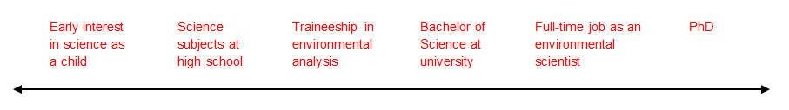

2 What sort of activities does Jenny complete throughout her workday?

She may be involved in various tasks such as fieldwork, writing reports and scientific papers, laboratory work, compiling data and attending conferences.

3 In your own words, why is the study of air quality in the home important for the health of individuals?

Answers will vary, but could include references to conditions of the lungs, heart, blood and breathing-related problems such as asthma.

4 Beijing, the capital of China, has been suffering severe air pollution for many years now. What do you think could be contributing to the air quality issues in Beijing?

Answers will vary, but could include industry (factories), vehicles (around 5 million cars are in Beijing alone) and high-density living.

5 How do you think Beijing could improve its air quality?

Answers will vary, but could include the addition of green wedges (corridors of plant life to help filter the air) and increasing public transport so that fewer cars are contributing to the air pollution.